Switching Regulator Component Selection Summary
Seth Ricks
11/27/2025
ECEN 390

Switching Regulator Component Selection Summary
(jas, Switching Regulator Component Selection Summary.docx, 11/27/2025)

For this portion of the Switching Regulator Project, complete the table below with your desired output voltage, along with the necessary calculations. Include your calculations below the table, as points will be deducted for correct values without including the necessary calculations.

- Standard 1% resistors are limited to the following numerical values per decade of resistor values:
10.0 | 10.2 | 10.5 | 10.7 | 11.0 | 11.3 | 11.5 | 11.8 | 12.1 | 12.4 | 12.7 | 13.0
13.3 | 13.7 | 14.0 | 14.3 | 14.7 | 15.0 | 15.4 | 15.8 | 16.2 | 16.5 | 16.9 | 17.4
17.8 | 18.2 | 18.7 | 19.1 | 19.6 | 20.0 | 20.5 | 21.0 | 21.5 | 22.1 | 22.6 | 23.2
23.7 | 24.3 | 24.9 | 25.5 | 26.1 | 26.7 | 27.4 | 28.0 | 28.7 | 29.4 | 30.1 | 30.9
31.6 | 32.4 | 33.2 | 34.0 | 34.8 | 35.7 | 36.5 | 37.4 | 38.3 | 39.2 | 40.2 | 41.2
42.2 | 43.2 | 44.2 | 45.3 | 46.4 | 47.5 | 48.7 | 49.9 | 51.1 | 52.3 | 53.6 | 54.9
56.2 | 57.6 | 59.0 | 60.4 | 61.9 | 63.4 | 64.9 | 66.5 | 68.1 | 69.8 | 71.5 | 73.2
75.0 | 76.8 | 78.7 | 80.6 | 82.5 | 84.5 | 86.6 | 88.7 | 90.9 | 93.1 | 95.3 | 97.6
For example, 1.00 Ω, 10.0 Ω, 100 Ω, 1.00 kΩ, 10.0 kΩ, 100 kΩ, etc., are standard 1% values.

- Standard 10% capacitor values are limited to the following numerical values per decade of capacitor values: 10, 12, 15, 18, 22, 27, 33, 39, 47, 56, 68, and 82.
Include your calculations and parts selection below for the following component values for your DC power supply: R1 and R2, L1 along with Chosen Inductor, C_{out} along with Chosen Capacitor, I_{D_Avg} along with Chosen Catch Diode. Points will be deducted for missing calculations.

R1 and R2
R2: $Greater than 100 kΩ→1.02MΩ$
$$R2=1.02 MΩ$$
$$R1=R2 \left(\frac{V_{out}}{1.19V}-1\right)=\left(1.02MΩ\right)\left(\frac{5.0V}{1.19V}-1\right)=3.27MΩ≈3.24 MΩ$$
$$R1=3.24 MΩ$$

L1 along with Chosen Inductor
$$L1=\frac{V_{out}+0.5V}{800kHz}=\frac{5.0V+0.5V}{800kHz}=6.875μH$$
$$L1=6.875μH$$

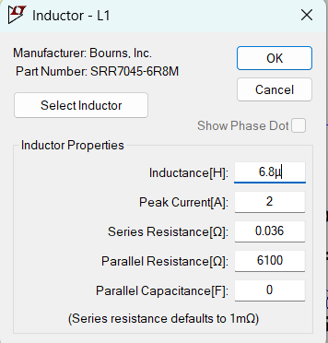
Chosen Inductor: SRR7045-6R8M, 6.8$μ$H, 2A Peak Current

C_{out} along with Chosen Capacitor
$$C_{out}=\frac{100}{V_{out}f_{sw}}=\frac{100}{\left(5.0V\right)\left(800kHz\right)}=25.0μF≈27.0μF$$
$$C_{out}=25.0μF$$
$$Chosen Capacitor:27.0μF$$

I_{D_Avg} along with Chosen Catch Diode
$$I_{D_Avg}=\left(1A\right)\frac{24V-V_{out}}{24V}=\left(1A\right)\frac{24V-5.0V}{24V}=0.792A$$
$$I_{D_Avg}=0.792A$$
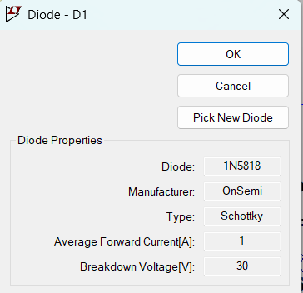
Chosen Catch Diode: 1N5818, forward current = 1A, Reverse Breakdown = 30V

After performing the calculations, check your values by downloading and running the calcCheck_Student.m MATLAB script. This can be done using a downloaded version of MATLAB on your desktop/laptop or using MATLAB Online. The MATLAB file calcCheck_Student.m provides a quick check of your calculations and chosen values.

Replace the Ranges of Values in the Table below with your chosen and calculated values.

Table 1: Power Supply Design Chosen and Calculated Values.
V_{out} Chosen | 5.0 V
R2 | 1.02M$Ω$
R1 | $$3.24MΩ$$
R1 + R2 | $$4.26MΩ$$
L1 Calculated | $$6.875μH$$
Part number, inductance value and peak current of chosen inductor L1 | SRR7045-6R8M, 6.8$μ$H, 2A Peak Current
C_{out} Calculated | $$25.0μF$$
C_{out} Chosen | $$27.0μF$$
I_{D_Avg} | $$0.792 A$$
Part number, forward current and reverse breakdown voltage of chosen catch diode D1 | 1N5818, forward current = 1A, Reverse Breakdown = 30V

